# Week 3 Homework:

1. Recreate the Patterned part from the lesson as a sketch pattern:

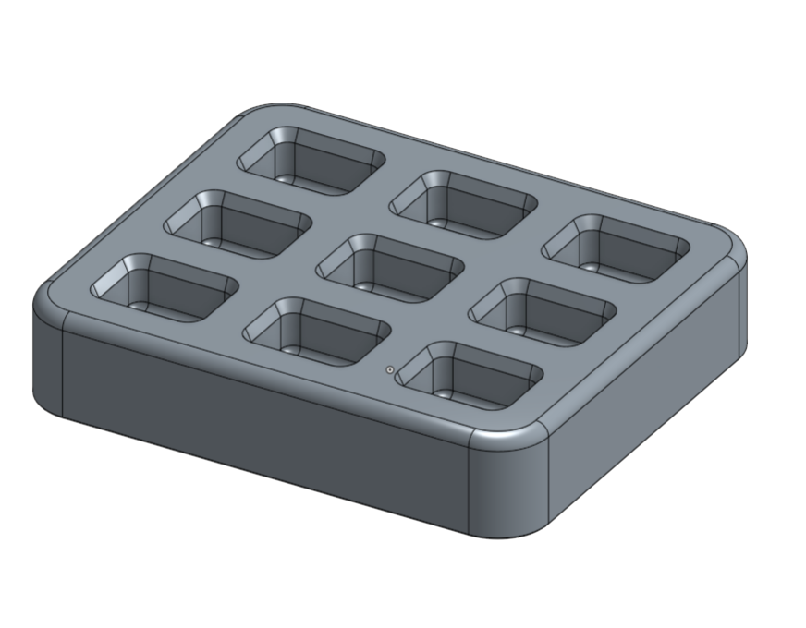

1. Starting with the CAD models located [here](https://cad.onshape.com/documents/7b5553135cdf6caafa9a6946/w/549bd8008ce6e8a13dc6b6cf/e/27159315ac3670adb78c8eec), complete the following geometry:
   1. Use both a circular pattern (8 X 360°) and a Linear Pattern (3 X 2”) to create the following geometry:

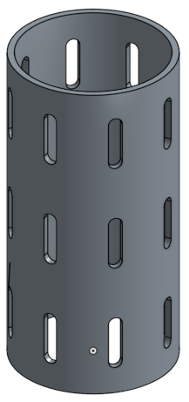

* 1. Starting with the two sketches provided, create the following backyard grill grate, with 1” gaps, using the following three methods (extrude them up to the outer ring):
     1. Sketch pattern the grill grate cross-section
     2. Feature pattern the grill grate extrudes (try doing it with a single pattern!)
     3. Part pattern the grill grates (use booleans to “trim” the grates using the outer ring)

What are the pros and cons of each method?

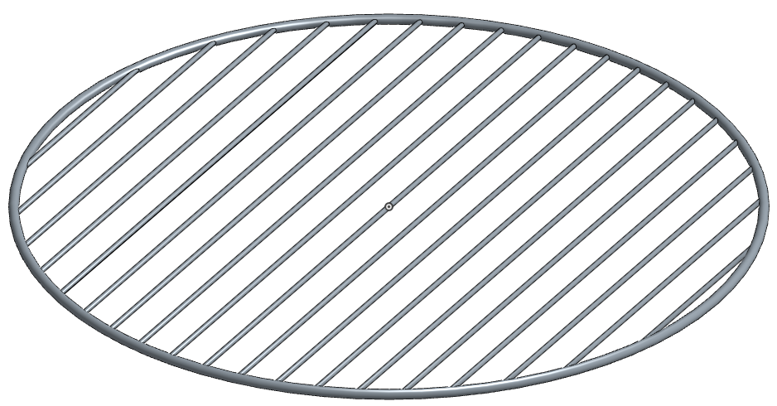

* 1. Create this multi-part ball bearing design, starting with nothing but the provided sketch, highlighted in orange. Don’t forget the 0.1” fillets at the end!:

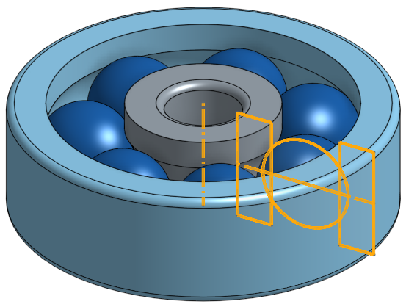

* 1. Create the following screwdriver model, given the existing sketches, and using the following workflow:
     1. Revolve the Driver, Handle, and Grip parts from the initial Profile sketch.
     2. Revolve the Bump Profile as a new part
     3. Circular Pattern the Bump Profile (6X)
     4. Boolean Union the Bump Profiles to the Grip Part
     5. Boolean Subtract the Handle from the Grip
     6. Sweep remove the Driver tip given the Profile & Path sketches.
     7. Circular pattern the Driver tip geometry (4X)

